17/08/2023

**Report on Technical Talk on Career Guidance and Enhancement of communication skill**

Objective: A talk on “**Career Guidance and Enhancement of communication skill** ” was conducted by IS department on August 17th for students of 4th semester.

Speaker – Ms. Amisha Srivastava.

The technical talk on “career guidance and communication skills” aimed to provide attendees with valuable insights into the significance of career guidance and effective communication skills in today’s professional landscape. The speaker was Ms. Amisha Srivastava, an alumnus of Department of ISE,VVCE, Mysuru.

The session began by emphasizing the importance of proper career guidance in helping individuals make informed decisions about their career paths. The speaker highlighted the role of self-assessment in identifying one’s strengths, Interests, and values, which are crucial in aligning career choices with personal attributes. It also highlighted the enhancement of communication skills, thereby preparing individuals for successful careers.

The following are the key points discussed during the talk,

* **Interview Preparation:** The interview tips and techniques were provided. The importance of communication skills to make a lasting impression was discussed.
* **Networking:** Effective networking to establish professional connections which could be established using the platform like LinkedIn was discussed.
* **Public Speaking:** Confidently presenting ideas is invaluable in professional growth.

The talk concluded with an engaging Q&A session, during which attendees had the opportunity to interact with Ms.Amisha. Participants raised thought-provoking questions related to career choices, communication challenges and strategies for overcoming them.

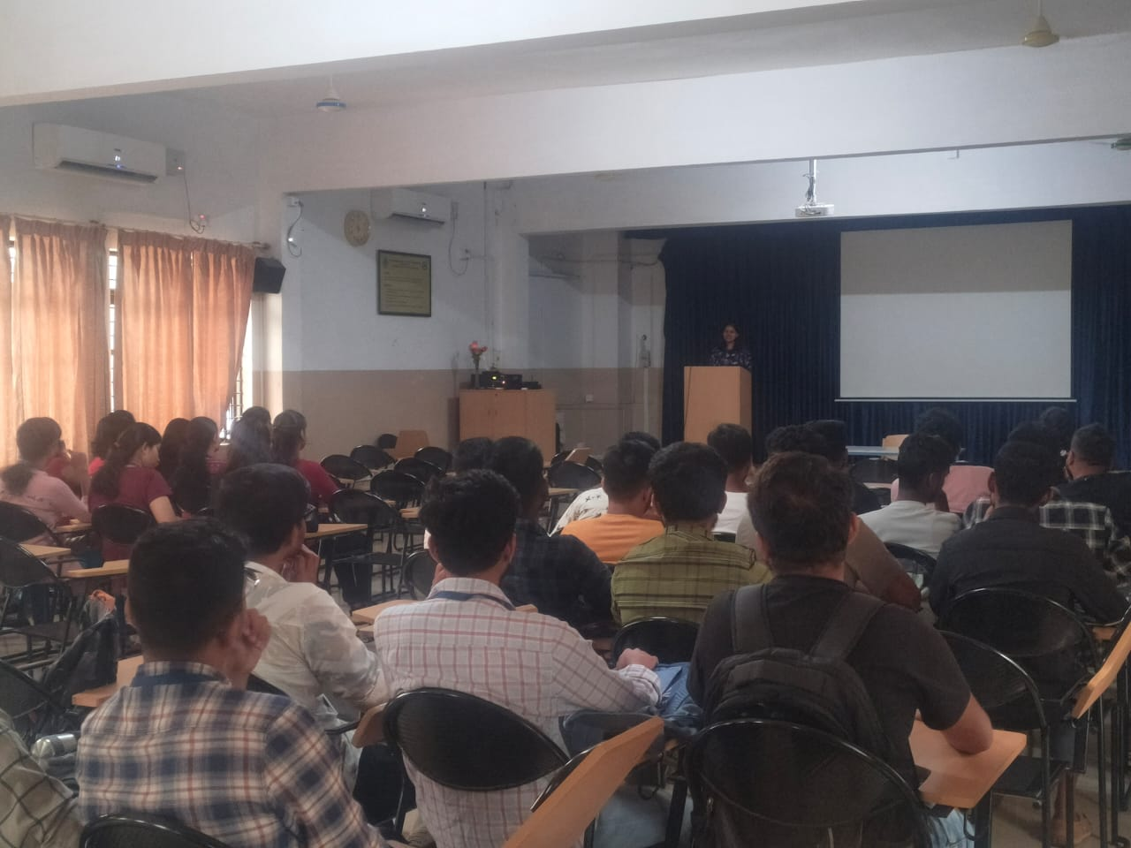 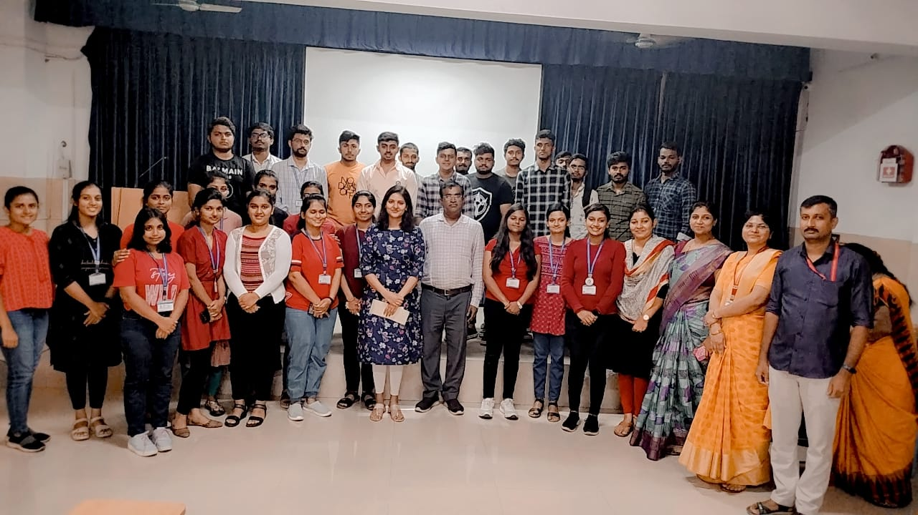

**Coordinators, Signature of the HOD**

Prof. Shilpa KS

Prof. Vidyashree KP Dr. AB Rajendra

Prof. Shivani TJ